

OFFICE FOR STUDENTS WITH DISABILITIES FACULTY HANDBOOK

Normandale Community College is a member of the Minnesota State Colleges and Universities and is an Equal Opportunity employer and educator. This document is available in alternative formats to individuals with disabilities by calling 952-358-8625 or emailing osd@normandale.edu.

normandale.edu/_files/documents/osd/FacultyHandbook.pdf Updated 7-8-2026
Table of Contents
OFFICE FOR STUDENTS WITH DISABILITIES FACULTY HANDBOOK 0
OSD Staff 3
The Law: 1
ACCOMMODATIONS 2
What is an accommodation? 2
How does a student become eligible for accommodations? 2
What are some examples of accommodations provided at Normandale? 2
What services are not provided at Normandale through the OSD? 2
Implementing Accommodations 2
Alternative testing 3
Note taking 3
Scribe/Lab Assistant 3
Adjustable tables or chairs 3
Sign language 4
Emergency Disability-Related Situations 4
Service Dogs 4
Student May Need to Leave Class for a Short Amount of Time 4
Other accommodations 4
Confidentiality 4
RIGHTS AND RESPONSIBILITIES 4
Rights of Students 4
Responsibilities of Students 4
Rights of Normandale Community College 5
Responsibilities of Normandale Community College 5
If an instructor IS notified by the Office for Students with Disabilities 5
If an instructor IS NOT notified 5
TEACHING STUDENTS WITH DISABILITIES 5
Non-Apparent Disabilities 5
Types of Non-Apparent Disabilities 6
Medical/Mobility Impairments 11
Sensory Impairments 12
CONSIDERATIONS FOR TEACHING ALL STUDENTS WITH DISABILITIES 14
Universal Design for Learning 14
Comprehensive Syllabus 14
Lectures 15
Guided Notes 15
Title II Digital Accessibility Compliance 15
Student Expectations 15
Inappropriate Behavior 16
WEB LINKS 16
RESOURCES 17
OSD FORMS (See Appendices) 17
Explanation of OSD Forms 17
Other Helpful Forms 17



OSD Staff

Kayla Allen
OSD Director
Office: L1754
952-358-9409
952-358-8619 FAX
Kayla.Allen@normandale.edu
Geri Wilson
Lead Sign Language Interpreter
Office: L1750
952-358-8596
Geri.Wilson@normandale.edu
Shelly Oliver
Make-Up Testing/Captioning Coordinator
Office: L1750
952-358-8590
Shelly.Oliver@normandale.edu
Patty Wallsch
Accommodations Coordinator
Office: L1750
952-358-8215
Patricia.Wallsch@normandale.edu
Lauren Clark
Accessibility Specialist
Office: L1753
952-358-8607
Lauren.Clark@normandale.edu
Chris Luhmann
Accessibility Specialist
Office: L1755
952-358-8174
Chris.Luhmann@normandale.edu
Kendra Weinrich
Accessibility Specialist
Office: 1755
952-358-8622
Kendra.Weinrich@normandale.edu

The Office for Students with Disabilities (OSD) is Normandale’s program to provide accommodations for students with disabilities. The goal of the program is to offer students with documented disabilities equal access to Normandale Community College courses, programs, and events through appropriate and reasonable accommodations.

This document is available in alternative formats
for individuals with disabilities by calling 952-358-8625.

The Law:

- What is the ADA?

The Americans with Disabilities Act (1990, 2008) includes basic civil rights guaranteed for people in the United States who have disabilities. With regard to colleges and college students, the ADA upholds and extends the standards set forth in Section 504 of the Rehabilitation Act of 1973 which states that:

“No otherwise qualified person with a disability in the United States shall, solely by reason of… disability, be denied the benefits of, be excluded from participation in, or be subjected to discrimination under any program or activity receiving federal financial assistance.”

- An otherwise qualified person includes:

A student who meets the admission requirements for the college.

- A person with a disability includes:

“Any person who (1) has a physical or mental impairment which substantially limits one or more major life activities, (2) has a record of such an impairment, or (3) is regarded as having such an impairment.”

- For college accommodation purposes a person with disability includes:

Any person who has a physical or mental impairment that substantially limits one or more major life activities. Major life activities may include: seeing, hearing, speaking, walking, breathing, sleeping, caring for oneself, performing manual tasks, learning, working, standing, lifting, concentrating, and interacting with others.

According to the law, college faculty are obligated to implement accommodations approved by OSD for students with disabilities.

Eligible students are those who meet admission requirements, have documentation of a disability, and have met with the Office for Students with Disabilities in advance of a request for accommodations. However, certain programs have additional technical standards that exceed the standards for college admittance. If this is the case, students who are registered with the OSD must meet these standards, but the standards must be applied so that they do not discriminate against a student with a disability or any student.

ACCOMMODATIONS

What is an accommodation?
An accommodation is a support that gives a student with a disability an equal opportunity to participate in and to benefit from school. The law requires colleges to provide accommodations for qualified students.

How does a student become eligible for accommodations?
First, students must be admitted to Normandale Community College. Then students must make an appointment to see an OSD staff person for an intake interview and at that time present documentation of their disability. This documentation may include high school special education records or a report from a licensed psychologist, disability specialist, or medical doctor. Once students have presented documentation of their disability along with having a staff consultation, a variety of accommodations may be provided which are determined on a case-by-case basis.

What are some examples of accommodations provided at Normandale?
- Alternative testing
- Note taking or permission to audio record lectures
- Organization or time management assistance
- Adjustable tables or chairs
- Audio/e-textbooks
- Sign language interpreting
- Provision of and/or orientation to assistive technology
- Other reasonable accommodations

What services are not provided at Normandale through the OSD?
  - Personal devices such as wheelchairs, hearing aids, glasses, or personal care services
  - Transportation
  - Assistance with homework or tutoring
  - Accommodations that lower or change classroom or program standards
  - Accommodations that are not reasonable
  - Accommodations that would change the essence of a program

- If an instructor questions the appropriateness of accommodations:
If a faculty member has questions about the appropriateness of a particular accommodation, please call Kayla Allen, the Director of the Office for Students with Disabilities at 952-358-9409, Lauren Clark, Accessibility Specialist at 952-358-8607, Chris Luhmann, Accessibility Specialist at 952-358-8174, or Kendra Weinrich, Accessibility Specialist at 952-358-8622 to discuss concerns.

Implementing Accommodations

Student accommodation requests are established and approved through the OSD. Each semester instructors will receive a letter listing each registered OSD student in their classes, detailing accommodations for which the student is eligible (See Appendix A for example). If a faculty member receives a request for an accommodation not listed on this letter, please refer the student to Kayla Allen, Lauren Clark, Chris Luhmann, or Kendra Weinrich.

Procedures for implementing accommodations:

Alternative testing
Alternative testing may include extended time, testing in a quiet room, test questions provided in an audio format, enlarged print, use of a computer, or use of a scribe. Each semester an eligible student will bring the instructor the confidential “Testing Accommodation Letter” (see Appendix B for an example of this letter) to request use of their testing accommodations. This letter will state what particular accommodation(s) the student receives. Also, 3-4 days before each test the student should bring the instructor a purple alternative testing form (see Appendix C for a screenshot of this form). The instructor should complete this form and return it with the test to the OSD office in L1750, to the after-hours drop-off slot outside the OSD office or via email to osd@normandale.edu.

The OSD staff can assist with necessary accessibility modifications to the test, such as text enlargement or test questions provided in an audio format (text-to-speech). For students with an accommodation for the test to be provided in an audio format, please email a digital copy of the test (preferably in a Word document) to osd@normandale.edu. Two days’ notice is requested if the test questions need to be provided in an audio format or enlarged. The OSD or testing center staff will proctor the test in the allotted time for the student. The student should, whenever possible, take the test at the same time as the class (sometimes not possible because of evening or weekend classes). Completed tests are delivered to instructors’ mailboxes that evening. To make special arrangements concerning the delivery of a test, please call the OSD at 8625 or write it on the purple form.

Note taking
Students with disabilities that impact their writing and/or notetaking ability may be eligible for note taking assistance. At Normandale, note taking support is provided in several ways. Some students may have an accommodation for permission to audio record lectures using their cell phone, tablet or laptop and may access a number of free or low cost audio recording software options. Students are instructed not to share the recordings with other individuals or online, unless they have an instructor’s permission to do so.

Other students may be eligible for a student notetaker or access to classroom presentation slides, depending on the format of the class. Students should attend at least one to two class sessions before requesting a student notetaker, as it may be that presentation materials and notes provided to all students by the instructor will meet the student’s needs. To start the process of requesting a student notetaker, students may email osd@normandale.edu. OSD staff will then recruit volunteer note takers to make copies of their notes for the eligible students. The OSD may ask instructors for suggestions in recruiting for a class.

The volunteers will either come to the OSD office and copy their notes using our copier, use carbonless NCR paper to produce the copies in class, or e-mail a copy to the OSD student or upload the notes to a cloud folder. These options are at no cost to the volunteers.

Scribe/Lab Assistant
Occasionally, a student worker or OSD staff member will serve as a lab assistant or scribe in a class. This is usually for labs or for classes that require frequent in-class writing. The OSD will collaborate with the instructor prior to the semester if a student may need this in a course.

Adjustable tables or chairs
Special tables and chairs are available through the OSD office; most rooms are equipped with adjustable tables. If a student requests a table or chair, have them contact the OSD.

Sign language
All interpreting services for students are arranged through the OSD. If a student in your class uses an interpreter and you are not familiar with this accommodation, contact the OSD with any questions you have. The interpreter will sit or stand near the instructor for optimal access during class. Please remember to address the student, not the interpreter. See Appendix E for further information.

Emergency Disability-Related Situations
Students may inform faculty that they are experiencing a disability-related situation, including an emergency hospitalization or the need for inpatient care. Please reach out to the OSD staff to discuss the situation and how the absence is impacting their course. The OSD staff will contact the student and may ask for supporting documentation. Our staff will connect back with the faculty member to facilitate a plan for the student to potentially make up missed work. A reasonable plan is determined in each situation, case-by-case, with faculty input.

Service Dogs
Students with a disability using a service dog are encouraged to register with the OSD, but are not required to do so. If the student does register with the OSD, the faculty will be notified that the service dog may be joining the student in class. For questions or concerns, such as whether an animal may meet the requirements of a service dog, please reach out to the OSD for assistance.

Student May Need to Leave Class for a Short Amount of Time
Student may need to leave class or turn off their webcam during a Zoom lecture for a short time (usually 5-10 minutes) for a disability-related reason. This is intended to be used when absolutely necessary, but not regularly. Student should follow up after class to find out what was missed during that short time period. Contact the OSD about overutilization of this accommodation.

Other accommodations
Other accommodations are dealt with on a case-by-case basis in consultation with the student, instructor, and the OSD staff.

Confidentiality
Please maintain the confidentiality of the students in your classes registered with the OSD office.

RIGHTS AND RESPONSIBILITIES

Rights of Students
- The right to equal access to postsecondary education
- The right to not be discriminated against
- The right to participate in and enjoy the benefits of school
- The right to an accessible education
- The right to an appropriate postsecondary accommodation
- The right to have information about a disability kept private

Responsibilities of Students
- Self-identify disability status to OSD
- Provide recent documentation about disability
- Request necessary accommodations in a timely manner
- Follow all Normandale and OSD policies and procedures
- Meet and maintain the same academic qualifications and essential institutional standards as other students on campus
- Follow the college’s student code of conduct as all students on campus

Rights of Normandale Community College
- Identify and establish essential functions, abilities, skills, knowledge, and standards for courses, programs, services, jobs, activities, and facilities and to evaluate accordingly
- Request and receive, through the OSD, current documentation from a qualified professional that supports requests for accommodations and services
- Deny requests for accommodations if the documentation does not demonstrate that the request is disability-related, if the individual fails to provide appropriate documentation, or if the request would fundamentally alter the nature of a program or the academic requirements considered essential to a program of study or to meet licensing requirements
- Select among equally effective accommodations, adjustments, and/or auxiliary aids and services
- Refuse to provide an auxiliary aid or incur an expense if it constitutes undue hardship to the college

Responsibilities of Normandale Community College
- Accommodate the known limitations of an otherwise qualified student with a disability
- Provide information to students, faculty, staff, and guests with disabilities in accessible formats upon request
- Evaluate students on their abilities, not their disabilities
- Provide or arrange accommodations, academic adjustments, and/or auxiliary aids for students, faculty, staff, and guests with disabilities
- Maintain appropriate confidentiality of records and communication
- Maintain academic standards by providing accommodations without compromising the content, quality, or level of instruction

If an instructor IS notified by the Office for Students with Disabilities
Faculty members have the responsibility to cooperate with the OSD in providing authorized accommodations in a reasonable and timely manner. Questions or problems regarding implementation of an accommodation should be discussed with Kayla Allen, Lauren Clark, Chris Luhmann, or Kendra Weinrich.

If an instructor IS NOT notified
If a student requests an accommodation and the faculty member has not been notified of the student’s eligibility for accommodations, then the faculty member should refer the student to the OSD.

TEACHING STUDENTS WITH DISABILITIES

Non-Apparent Disabilities

Non-apparent disabilities are the most common type of disability among college students. For example, students with learning disabilities, Attention Deficit Hyperactivity Disorder and/or psychiatric disabilities may request accommodations even though they do not appear to have a disability. There are numerous other hidden or non-apparent disabilities such as a heart condition, Chronic Fatigue Syndrome, Fibromyalgia, and Seizure Disorder. It is important to remember that the severity of functional limitations do not depend on the ability to see the disability.

Types of Non-Apparent Disabilities

Learning Disabilities

Students with learning disabilities often learn differently than their peers. Although they have average or above average intelligence, there is frequently a discrepancy between their ability and their achievement in specific areas due to a central nervous system dysfunction. A learning disability is a permanent disorder that interferes with integrating, acquiring, and/or demonstrating verbal or nonverbal abilities and skills. Frequently, there are some processing or memory deficits.

Each student with a learning disability may need different types of accommodations based on what area(s) of learning is affected by the disability. Students with learning disabilities will have difficulties with some of the following: reading comprehension, written expression, mathematics, oral expression, auditory processing, visual processing, abstract reasoning, processing speed, visual spatial skills. Keep in mind that no one individual has difficulty with all of the above areas, generally just a few. Also, it is not unusual for a person with a learning disability to be gifted in some areas.

A learning disability is not a disease, so there is no cure, but there are ways to overcome the challenges it poses through identification and accommodation.

Some examples of a specific learning disability include:
- Dyslexia – difficulty with reading, writing and spelling
- Dyscalculia – difficulty with math functions and using numbers
- Dysgraphia – difficulty with psychomotor skills needed for writing
- Auditory Processing Disorder – difficulty interpreting auditory information
- Expressive Language Disorder – difficulty expressing self in language
Possible Accommodations for Students with Learning Disabilities:
Accommodations are determined on a case-by-case basis depending on the student’s current functional limitations resulting from their disability or qualifying diagnosis and from the barriers created by their current learning environment. Based on the nature of the learning areas affected, typical accommodations may include:
  - Extended time for testing
  - Testing in a quiet space
  - Test questions provided in an audio format
  - Note taking support
  - Alternative format textbooks
  - Audio recording lectures

Attention Deficit Hyperactivity Disorder (ADHD)
Attention deficit hyperactivity disorder is characterized by a persistent pattern of inattention and/or hyperactivity that is more frequent and severe than is typically observed in individuals at a comparable level of development. Students with ADHD will have difficulty with one or more of the following areas: concentration, distractibility, organization, completing tasks, following directions, listening, sitting for lengthy periods.

Possible Accommodations for Students with ADHD:
- Testing in a quiet area with few distractions
- Extended time for testing
- Note taking support
- Preferential classroom seating
- Time management assistance
- Audio recording lectures

Mental Health Disabilities

Students with mental health disabilities exhibit “… a persistent psychological disorder or psychiatric disorder, emotional or mental illness that adversely affects educational performance and/or functioning and frequently requires medication” (College Students: Mental Health Problems and Treatment Considerations). Descriptions of certain types of psychiatric disorders follow:

Depression is a major disorder that can begin at any age. Major depression may be characterized by a depressed mood most of each day, a lack of pleasure in most activities, thoughts of suicide, insomnia, and feelings of worthlessness or guilt.

Symptoms of Depression include:
- A persistent sad, anxious, or “empty” mood
- Sleeping too little or sleeping too much
- Reduced appetite and weight loss, or increased appetite and weight gain
- Loss of interest or pleasure in activities once enjoyed
- Restlessness or irritability
- Persistent physical symptoms that don’t respond to treatment (such as headaches, chronic pain, or constipation and other digestive disorders)
- Difficulty concentrating, remembering, or making decisions
- Fatigue or loss of energy
- Feeling guilty, hopeless or worthless
- Thoughts of death or suicide

Untreated depression is the number one cause of suicide. Any talk of suicide by a student needs to be taken seriously and help sought immediately. Express your concern to the student and make a referral to the Care Team, college Advising, Counseling, and Career office (952-358-8261), Public Safety (555 or 952-358-8280), or call emergency 911.

Emergency suicide interventions are available through 911, 988, or COPE at 612-596-1223.

Bipolar disorder (manic depressive disorder) causes a person to experience periods of mania and depression. In the manic phase, a person might experience inflated self-esteem and a decreased need to sleep; however, in the depressive phase, a person may experience a lack of energy and less self-esteem and interest in family, friends, and school.

Dysthymia is a form of depression that is less severe than major depression; however, it involves long-term, chronic symptoms that do not disable but keep one from functioning well or from feeling good.

Seasonal Affective Disorder (SAD) is associated with depressive episodes that occur during the winter months (especially in the northern climates), with symptoms subsiding during the spring and summer months. These depressive episodes are related to seasonal variations of light. The most difficult months for people with SAD are January and February.

Anxiety disorders can disrupt a person’s ability to concentrate and cause hyperventilation, a racing heart, chest pains, dizziness, panic, and extreme fear. Examples of anxiety disorders include panic disorder, simple phobias, and Obsessive-Compulsive Disorder (OCD).

General Anxiety Disorder (GAD) is characterized by excessive, unrealistic worry that lasts six months or more. In adults, the anxiety may focus on issues such as health, money, relationships, or career. In addition to chronic worry, GAD symptoms may include trembling, muscular aches, insomnia, abdominal upsets, dizziness, and irritability.

Obsessive-Compulsive Disorder (OCD). Individuals with OCD are plagued by persistent, recurring thoughts (obsessions) that reflect exaggerated anxiety or fears. Typical obsessions include worry about being contaminated or fears of behaving improperly or acting violently. The obsessions may lead an individual to perform a ritual or routine (compulsion) such as repetitive counting or hand washing.

Panic Disorder. People with panic disorder suffer severe attacks of panic – which may make them feel like they are having a heart attack or are “going crazy” for no apparent reason. Symptoms include heart palpitations, chest pain or discomfort, sweating, trembling, tingling sensations, feeling of choking, fear of dying, fear of losing control, and/or feelings of unreality. Panic disorder often occurs with agoraphobia, in which people are afraid of having a panic attack in a place from which escape would be difficult, so they avoid these places.

Post-Traumatic Stress Disorder (PTSD). PTSD can follow an exposure to a traumatic event such as a sexual or physical assault, witnessing a death, the unexpected death of a loved one, or natural disaster. There are three main symptoms associated with PTSD: 1. “reliving” the traumatic event (such as flashbacks and nightmares); 2. avoidance behaviors (such as avoiding places related to the trauma); and 3. physiological arousal such as difficulty sleeping, irritability or poor concentration.

Social Anxiety Disorder (Social Phobia). Social Anxiety Disorder is characterized by extreme anxiety about being judged by others or behaving in a way that might cause embarrassment or ridicule. This intense anxiety may lead to avoidance behavior. Physical symptoms associated with this disorder include heart palpitations, faintness, blushing and/or profuse sweating.

Specific phobias. People with specific phobias suffer from an intense fear reaction to a specific object or situation (such as spiders, dogs, or heights); the level of fear is usually inappropriate to the situation, and is recognized by the sufferer as being irrational. This inordinate fear can lead to the avoidance of common, everyday situations.

Schizophrenia affects how a person thinks, feels and acts. People with schizophrenia may have difficulty distinguishing between what is real and what is imaginary. Others with this disorder may have difficulty behaving “normally” in social situations or may be withdrawn or unresponsive. Schizophrenia, however, is not split personality or multiple personality. The vast majority of people with schizophrenia are not violent and do not pose a danger to others. The signs of schizophrenia are different for everyone. Symptoms may develop slowly over a period of months or years or may appear suddenly. The disease may also appear in cycles of relapse and remission.

Behaviors or early warning signs of schizophrenia may include:
- Hearing or seeing something that isn’t there
- A constant feeling of being watched
- Unusual or nonsensical manner of speaking or writing
- Deterioration of academic or work performance
- Change in appearance or personal hygiene
- Increasing withdrawal from social situations
- Irrational, angry or fearful response to loved ones
- Inability to concentrate or sleep
- Excessive preoccupation with religion or occult

Symptoms of Schizophrenia may include:
- Delusions or false ideas
- Hallucinations – seeing, hearing, feeling, tasting, or smelling something that doesn’t exist
- Disordered thinking and speech
- Social withdrawal
- Extreme apathy
- Lack of drive or initiative
- Emotional unresponsiveness

Autism Spectrum Disorders (ASD) is a neurological and/or developmental condition that impacts how a person perceives and socializes with others, causing problems in social interaction and communication; it includes limited and repetitive patterns of behavior. The term "spectrum" refers to the wide range of symptoms and severity experienced by people with ASD.
Symptoms of ASD may include:
- Marked impairment in the use of multiple nonverbal behaviors (eye-to-eye gaze, facial expressions, and body postures)
- Failure to develop peer relationships appropriate to developmental level
- Lack of spontaneous seeking to share enjoyment, interests, or achievements with other people
- Apparently inflexible adherence to specific, nonfunctional routines or rituals.
- Persistent preoccupation with parts of objects
- Stereotyped and repetitive motor mannerisms (hand or finger flapping or twisting, or complex whole-body movements)
- Concrete thinking (versus abstract)
- Writing problems and difficulty with math
- Flat and emotionless voice
- Social awareness but inappropriate reciprocal interaction

Tourette’s Disorder. According to the American Psychiatric Association, DSM-V (2013), the essential features of Tourette’s Disorder are multiple motor tics and one or more vocal tics. A tic is a sudden rapid, recurrent, nonrhythmic, stereotyped motor movement or vocalization. Simple motor tics are: eye blinking, nose wrinkling, neck-jerking, shoulder shrugging, or facial grimacing. Simple vocal tics are meaningless words or sounds such as throat clearing, clicking, grunting, sniffing, snorting and/or coughing. Tics may occur many times a day recurrently throughout a period of more than a year. The symptoms may be lifelong, though periods of remission lasting from weeks to years may occur.

Eating Disorders. Individuals with eating disorders experience severe disturbances in their eating habits, including unhealthy reduction of food intake or unhealthy overeating. Eating disorders are real, treatable illnesses. Causes of eating disorders may include: low self-esteem, peer pressure to be thin, society or cultural pressures to be thin, or history of sexual abuse. Anorexia Nervosa and Bulimia Nervosa are the two most common types of eating disorders.

Anorexia Nervosa symptoms may include:
- Extreme weight loss
- The belief that one is fat despite excessive thinness
- Eats tiny portions of food, skips meals, and won’t eat in front of others
- Loses hair, appears pale in skin color, and wears baggy clothes to hide thinness
- Fears obesity and complains of being fat despite thinness
- Hates all or certain parts of body
- Excessive or compulsive exercise routine
- Perfectionist
- Becomes socially isolated
- Has difficulty expressing emotions, primarily anger
Bulimia Nervosa symptoms may include:
- Frequent acts of binge-eating and purging of food to prevent weight gain
- Buys binge food (primarily junk food or high-caloric foods)
- Uses water pills, diet pills or laxatives
- Abuses alcohol or drugs to suppress appetite or to escape emotional hurt
- Displays little impulse control – making poor decisions about sex, commitment, money, etc.

In most situations, you will not be aware that you have a student with a mental health disability in your classroom. Because students do not show any outward sign of the disability does not mean that their disability is any less disabling than a more visible disability. Many of these students are fearful of and have faced stigmatization because of their disability. Some do not need or request any accommodations, and some require a variety of accommodations. With medication and/or therapy, people with mental health disabilities may learn to manage their symptoms.

Possible Accommodations for students with mental health disabilities
- Extended time for testing
- Testing in a quiet space
- Allowing an anxious student to leave the room
- Notetaking support
- Audio recording lectures
- Alternative format textbooks

Possible Learning Strategies for students with non-apparent disabilities
- Seek support from OSD to set up and provide accommodations as early as possible.
- Use a planner to stay organized. Record assignments and test dates in the planner.
- The following are some study tips:
  - Underline or highlight important ideas for review
  - Read the chapter summary or end of chapter questions before starting the chapter
  - Use word processing to help with organizing, editing, and spell checking
  - Use an electronic dictionary and thesaurus
  - Use a recording software to record lectures—free or low cost audio recording software options
  - Schedule time to study with a peer or tutor
  - Focus on one class at a time and break tasks into smaller parts
  - Study in an area that aids concentration
  - Establish a sense of purpose to studying
  - Remember that irregular sleep, exercise, and eating patterns can cause concentration difficulties
  - Work in pairs, teams or small groups in order to learn from others
  - Use a think aloud technique, cue cards, and verbal reminders when studying and doing assignments

Medical/Mobility Impairments

Mobility impairments are often due to conditions such as cerebral palsy, multiple sclerosis, muscular dystrophy, or spinal cord injury. Students may use crutches, braces, or a wheelchair. Medical impairments are often non-apparent disabilities, caused by such conditions as arthritis, asthma, cancer, orthopedic limitations, post-surgery, Chronic Fatigue Syndrome, or seizure disorder. The student may have limited energy; difficulty walking, standing, or sitting for a long time; or other disabling characteristics, such as an inability to write.

Functional limitations may be episodic for some students who may experience dizziness, disorientation, and difficulty breathing during a recurrence. For example, with asthma or a seizure disorder, a student may have periods when he can function without any accommodations, but at other times functional limitations are quite severe.

Even with the same disability, students with mobility or medical impairments may have a wide variety of characteristics. For example, persons with a spinal cord injury are likely to show differing degrees of limitation. They may require different types of accommodations or may need no accommodations, depending on functional limitations.

Traumatic Brain Injury is typically a consequence of an accident, but can also be caused from a stroke, lack of oxygen, poisoning, tumor or an infection. At least 1.5 million people sustain traumatic brain injuries in this country every year. Students often display problems with attention deficit, memory and concentration.

The effects of the injury may be highly individual depending on the area of the brain affected. Students with TBI may experience frustration and anger often characterized by a quick temper. They typically exhibit discrepancies in abilities such as reading or spelling. Although there is great variation in the possible effects of a head injury, most injuries result in some degree of difficulties in the following functions:
- Memory – the primary difficulty is the inability to store information for immediate recall. However, long-term memory or previously acquired knowledge is usually intact.
- Cognitive/Perceptual Communication – students may have difficulty focusing for sufficient lengths of time for learning to take place. Attention and concentration may be influenced by medication, nutrition patterns, and fatigue resulting from disturbed sleep.
- Speed of thinking – it often takes the student longer to process information which influences reaction time, speed of response, and quickness of data integration.
- Communication – language function (writing, reading, speaking or listening) may be impaired. Problems in pragmatics may include interrupting, talking out of turn, dominating discussions, speaking too loudly or rudely, or standing too close to the listener. The student may have trouble comprehending written or spoken material especially under pressure such as during exams.
- Spatial Reasoning – refers to the ability to recognize shapes of objects, judge distances accurately, navigate, read a map, visualize images, comprehend mechanical functions, or recognize position in space.
- Conceptualization – TBI often reduces the ability to categorize, sequence, abstract, prioritize and generalize information. The student may be very concrete and stimulus-bound.

Possible Accommodations for students with mobility impairments
- Adjustable table or chair
- Notetaking support
- Extended time for testing
- Scribes for testing
- Computer use for essay tests
- Assistance with labs
- Assistance with in class writing
- Audio recording lectures

Sensory Impairments

Blind or Low Vision

Vision disabilities can result from a variety of causes, including: congenital conditions, injury, eye disease, brain trauma, diabetes, or multiple sclerosis. A person is considered legally blind if corrected vision is no better than 20/200, or if peripheral fields are no more than 20 degrees diameters or 10 degrees radius.
Eighty to ninety percent of people who are legally blind have some measurable vision or light perception. Even those students who may appear to travel and function without assistance are likely to still require some type of classroom accommodation. Most students with vision disabilities use a combination of adaptations for class participation including: readers, notetakers, Braille, books in alternate format, voice-synthesizing computers, and optical scanning or enlarging devices.
It should be noted that not all students who are blind can or want to read Braille. Some medical conditions may actually preclude that skill. Conditions (such as diabetes) may reduce sensation in the fingertips as a result of poor circulation, therefore limiting a person's ability to read Braille.

Instructional Strategies

- Provide a list of textbooks, assigned reading, and tests dates as far in advance as possible. Students may need to have books converted to an alternate format, which takes several weeks or months.
- Read any written material presented in class aloud to the whole class, so the student with low vision knows what information is being displayed. This includes materials on the board, overhead, flip-chart, PowerPoint, etc.
- For students with limited vision, use good contrast in printed materials. Write larger and darker when using the board.
- Create an environment as noise-free as possible. Unnecessary sounds can be distracting. For example, turn off the overhead projector when not in use.
- Verbally describe any essential pictures shared on the screen when using teaching aids such as videos, models, or slides. When physical teaching models are used, describe the model out loud to the whole class, and when possible, give students the option to feel the model if they would like to.
- Try to speak directly facing the class; turning your head away can muffle or distort the sound of your voice.
- Students with a vision disability may not see visual cues, so it is important for them to receive verbal cues. For example, avoid using words like “over there,” “in here,” and so on. Instead, try to be more specific. Say “over by the board in the front of the room.”
- Service dogs/Guide dogs are trained to provide tasks/services for the individual with a disability, and are expected to be well-behaved and under the student’s control at all times. They will require no special consideration with the possible exception of planning a field trip or a lab environment.
- Encourage the student to meet with you at the beginning of the semester to discuss any potential questions or concerns they may have or modifications that may be needed to the course content to make it accessible to them. You are welcome to consider an alternative form of an assignment if the original format creates an excessive burden for a student with a vision disability. It is important to remember that any alternative version should meet the same level of skill and effort as the original assignment.
- Invite students to proactively discuss timelines for projects and assignments with you. Information gathering and assistance from readers, notetakers, or volunteers may require additional time.
- Be prepared to give the student additional lead time to complete assignments that are due the same day they are assigned.
- The majority of students with vision-based disabilities will use audio recordings, laptops, or other assistive technology programs such as a screen reader software to help them navigate on the computer and take notes in class. They may also contact the OSD Office to request a student note taker to help them take notes during the live lecture component of the course.

Communication Suggestions

- Introduce yourself and anyone else present when speaking to a student with a vision disability.
- It is okay to use words such as "see" or "look," because students with low vision use these terms also.
- When walking with a student who has a vision disability, allow them to take your arm just above the elbow. Walk with a natural manner and pace.
- Give clear and accurate directions to a person with a vision disability. Use words such as left and right instead of “over there.”
- When guiding a person with a vision disability, slow down when you approach steps or obstacles and let them know what is in their path. Let the student know if you will be going up or down the stairs. When approaching a door, tell them if it needs to be pushed or pulled.
- When offering a seat to a student with a vision disability, place the student's hand on the back or arm of the chair. This gives the student a frame of reference to seat themselves.
- Let a student with a vision disability know when you are leaving a room.
- A guide dog is trained as a working animal and should not be petted or spoken to without the permission of the handler. A general rule of thumb is that the dog is working while in a harness.
- In case of emergencies, alert the student to the nature of the situation. Offer assistance to the student and guide them to the nearest emergency exit and away from the building to safety. Some types of emergencies require safety within a building. Depending upon the nature of the emergency, during crisis periods, there may be a lot of commotion and noise. A student with a vision disability may not be able to orient themselves as well as they can in calmer times. Your assistance is critical to their safety.

Possible accommodations for students who are blind or have a vision disability (always considered on an individual case-by-case basis)
  - Front of classroom seating
  - Notetaking support
  - Extended time on testing
  - Alternative format textbooks
  - Enlarged copies of tests, notes, handouts
  - Assistance with labs
  - Assistance with in class writing
  - Audio recording lectures

Deaf or Hard-of-Hearing

Not all students who are deaf or hard-of-hearing have the same characteristics. Individuals who are deaf rely upon visual input rather than auditory input when communicating. Some hard-of-hearing individuals have a measure of residual hearing and use a device to amplify sounds (Assistive Listening Device). Some choose to speak; others use very little or no oral communication. Some students are extremely adept at speech reading, while others have very limited ability to “read lips.” For some, sign language and/or fingerspelling are the preferred means of communication.

Possible Accommodations for students who are deaf or hard-of-hearing
- Sign language interpreter
- Closed captioning
- Front of classroom seating
- Note taker
- Assistive Listening Device (ALD)
- Transcriptionist or captioner

CONSIDERATIONS FOR TEACHING ALL STUDENTS WITH DISABILITIES

Universal Design for Learning

“Universal design is an approach to designing course instruction, materials, and content to benefit people of all learning styles without adaptation or retrofitting” (visit Fast Facts for Faculty or CAST UDL Guidelines for more information). By incorporating Universal Design principles in instruction that allow students with disabilities access to the classroom, you may also be designing instruction that works better for everyone in the class. Classes designed with this concept in mind offer a variety of methods of content presentation, flexible teaching strategies, and options for demonstrating mastery of course content.

Comprehensive Syllabus

A comprehensive syllabus with clearly delineated statements about expectations is helpful to students who need help with structure and organization. Students with early access to the course syllabus can order alternative format textbooks if necessary and balance their course load accordingly. Some need additional time to get started on the material for the course.

Items to Include on your Syllabus:
- State course goals and objectives
- Specify exam and assignment dates
- State office hours and encourage students to use them
- Detail assignments and papers for easy reference
- Detail grading and evaluation methods
- List course policies
- Provide as much information about lecture topics as possible
- Provide the ADA statement to encourage students with a documented disability to meet with an OSD staff member.

Syllabus Statement

Below is the statement that should be included in an instructor’s syllabus to inform students about the Office for Students with Disabilities:

Normandale Community College is committed to providing equal access for students with disabilities through the Office for Students with Disabilities (OSD). If you experience educational barriers because of a disability, please make an appointment for an intake/interview to discuss these needs and to implement appropriate accommodations for your Normandale courses. Schedule an appointment by calling the OSD staff at 952-358-8625, emailing osd@normandale.edu, online at normandale.edu/osd, or by stopping by the L1750 office.
This syllabus is available in alternate formats upon request.

Lectures

Since students have various learning styles, faculty could use a combination of delivery methods to enhance student learning and success for all students.

The following are some suggestions for presenting lecture material:
- Provide an outline with key concepts or vocabulary prior to lecture
- Write key terms and technical vocabulary on the board
- Link previous lecture to current lecture
- State class session objective
- Give more than adequate time for students to copy information from visual display or, better yet, provide a handout
- Make notes available on Desire2Learn
- Encourage students to read the text prior to the lecture discussion
- Summarize or draw conclusions at the end of the lecture
- Keep oral instructions concise and reinforce with cue words
- Repeat or reword complicated directions or provide a detailed handout of the directions
- Use everyday life analogies and examples to make abstract information easier to understand
- Leave time for questions

Guided Notes

Guided notes are instructor-prepared handouts that provide all students with background information and standard cues with specific spaces to write key facts, concepts, and/or relationships during a lecture. Students with complete and accurate notes that study them consistently receive higher test scores than students who only listen to a lecture and read the text.

Title II Digital Accessibility Compliance
Per requirements under Title II of the Americans with Disabilities Act (ADA), all digital materials, including web content and mobile applications has to meet WCAG 2.1 AA standards effective April 2027. One important aspect is that all members of campus continuously make a good faith effort toward digital compliance. Training materials to help make your course material accessible can be found via the Employee Exchange and the Tools and Resources for Faculty section on the OSD website. In addition, the Center for Teaching and Learning is also available to help answer questions and provide guidance by contacting accessibility@normandale.edu.

Student Expectations

Although many students with disabilities need accommodations, expect these students to perform at the same level as the rest of the class. Do not have a special grading scale or other criteria for them.

Inappropriate Behavior

Students with disabilities are subject to the code of conduct required of any student at Normandale Community College.

WEB LINKS

General
- Minnesota Disability Resources on the Web

- Minnesota State Council on Disability

Learning Disabilities
- LD Online

Mental Health Disabilities
- National Alliance on Mentally Illness (NAMI) Minnesota

- Normandale Counseling Department Resource Page
- Seasonal Affective Disorder

- Suicide information and help

Brain Injury
- Brain Injury Association of Minnesota

- Brain Injury Resource Center

RESOURCES

Accessibility Resources (2014, February 18). Retrieved from http://www.mnsu.edu/access/faculty/students/vision-loss.html

Disability Access Services Employee Guide Working with Students with Disabilities,
North Hennepin Community College

Improving the Quality of Education for Students with Disabilities, The Ohio State University Partnership Grant

Learning & Psychological Disabilities: Classroom Strategies, A Faculty Guide, Pine Technical College and Minnesota State Colleges and University Center for Teaching and Learning

University of Kansas Center for Research on Learning, Division of Adult Studies

OSD FORMS (See Appendices)

Explanation of OSD Forms

Appendix A. Accommodation Eligibility form. This form is emailed each semester to every instructor who has a student in their class that is registered with the OSD. The form states accommodations for which the student is eligible.

Appendix B. Testing Accommodation Letter. Alternative testing may include extended time, testing in a quiet room, test questions in audio format (“taped tests”), enlarged print, use of a computer, or use of a scribe. An eligible student will bring the instructor the confidential “Testing Accommodation Letter” to request alternative testing. This form will state what particular testing accommodation(s) the student receives.

Appendix C. Testing Accommodation purple form. For each exam, students will bring the instructor a purple alternative testing form. The instructor should complete this form and personally return it with the test to L1750, the OSD office.

Appendix D. Emergency Evacuation Plan. This form is sent to instructors who have students with mobility or vision disabilities. The OSD staff also reviews the evacuation information with the student during their intake meeting.

Appendix E. Questions and Answers about Interpreting. This form is sent to all faculty who have a student who is deaf and requires the services of a sign language interpreter.

Other Helpful Forms

Appendix F. Authorization for the Release of Student Information. If a student requests that a parent or other third party have the ability to discuss their FERPA-protected information, the student is required to sign a release. To find out if a student has an active release of information on file, contact the Records Office for further assistance.

Appendix A - Accommodation Eligibility Form

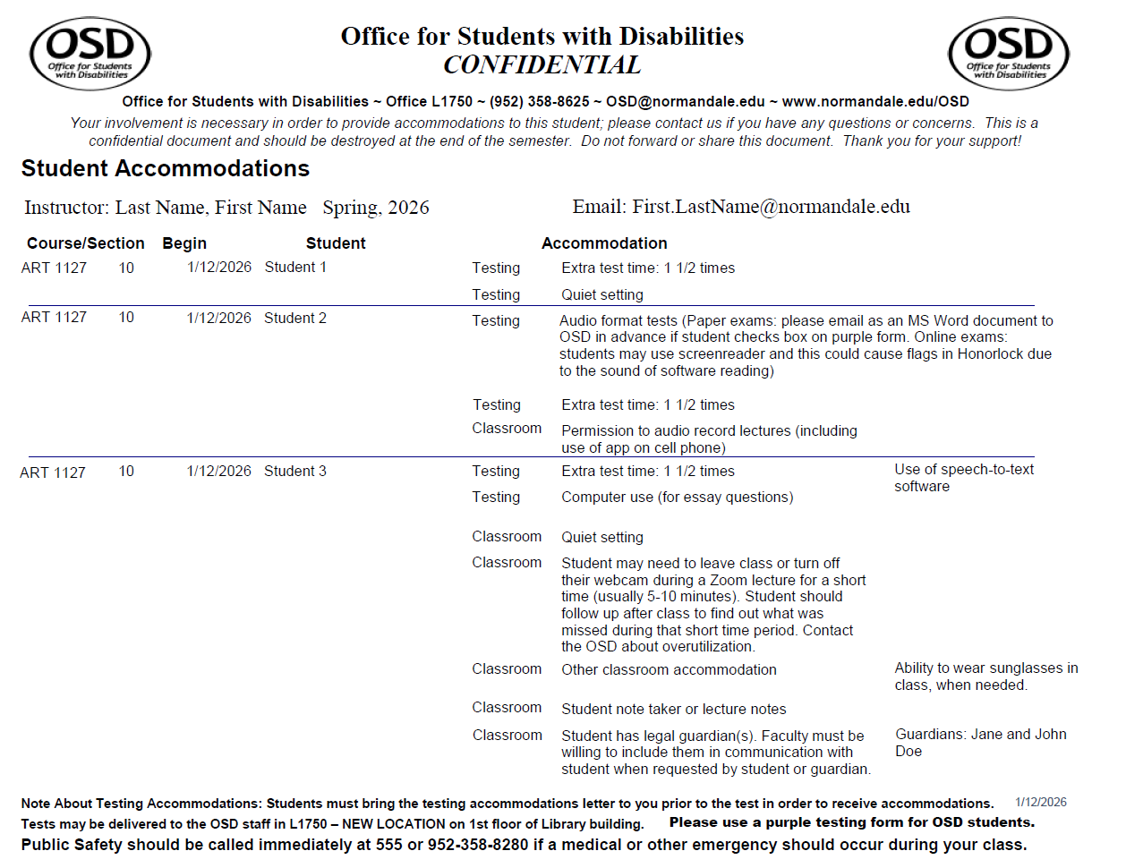

Appendix B - Testing Letter

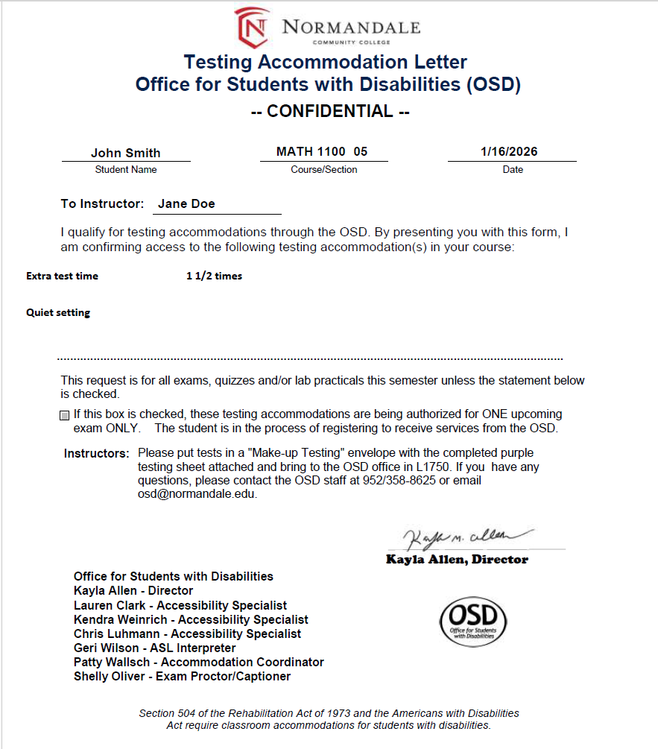

Appendix C - Purple Testing Form

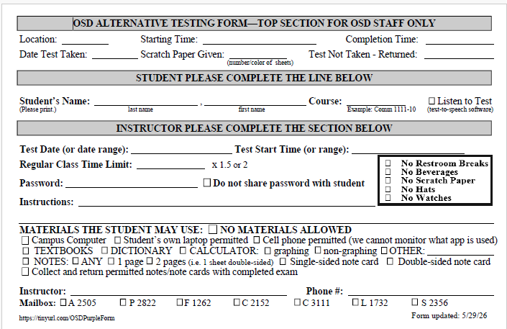

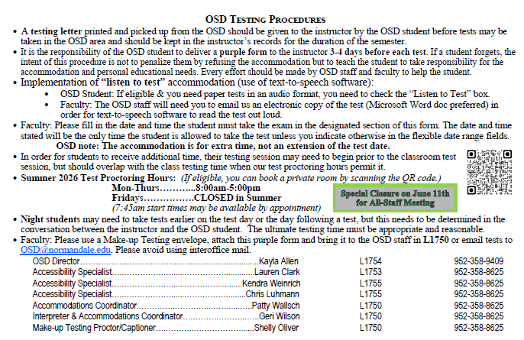

Appendix D - Emergency Evacuation/Severe Weather Plan for Students with Disabilities

In the event of an emergency alarm is sounded in any Normandale Community College building, it is important each person understands where to go and what to do to ensure a safe and timely campus evacuation.

Faculty Members: Students who have a mobility disability or vision loss will have evacuation information designated on their OSD accommodation plan that you receive at the beginning of each semester. In an emergency evacuation, stay with students in need, and ask them if they have a Personal Safety Plan arranged with the Public Safety Office or how you can best be of assistance during the evacuation procedure.

Students: Normandale’s Department of Public Safety offers students with disabilities the opportunity each semester to develop a Personal Safety Plan that may include the following safety interventions:
- A one-on-one meeting with Public Safety to discuss specific needs of the individual during an emergency.
- Campus maps of the areas the student frequents such as their classroom, study areas, or hangouts.
- Review of safety equipment that may be available to assist them in an emergency.
- A tour of evacuation routes, plus advice and tips for staying safe in an emergency on campus.
- Public Safety can be contacted at extension 555, 952-358-8280, or call 911 for assistance.
Here are some basic emergency guidelines that can help in an emergency:
- In the event of a fire, if possible, exit the building. If that is not feasible, we suggest three options:
- Relocate to another building on campus to allow fire personal an opportunity to contain and extinguish the fire.
- Have someone help you utilize an evacuation chair (see Evacuation Chair Section for locations)
- If either the two statements above are not feasible, get to the safest location possible and have a person that can exit the building inform fire personal where you are located, so additional help may be sent
- Never use elevators in a fire. Most buildings on campus have a ground floor exit easily accessible, and those that do not are equipped with an evacuation chair that can be used to safety bring students down stairs who may have difficulty doing so on their own. Designated safe areas have directions, maps, an analog phone, and space for at least two wheelchairs.
- The campus is protected by a fire sprinkler protection system. Smoke from a fire can be dangerous, so if possible, stay low and go.
- Severe weather shelter areas are usually on the lowest level of each building. Getting to one should be a priority. However, if time does not allow, bathrooms, closets, and interior windowless rooms are also good options.
- Never hesitate to request help from Normandale staff. If they cannot assist, they may organize others who can.
Evacuation Exits
- The first floors of all buildings have outdoor access.
- All areas on the second floor of the inner ring corridors have access to the outdoor courtyard area.

Evacuation Chair Locations– Below is a list of where each evacuation chair is located on campus:
- Activities: Located at the top of staircase A2 which is near the elevator mechanical room A2579 or near the 2nd floor Activities elevator.
- College Services: All Evac Chairs are located on the 3rd floor of College Services.
  - One is located in stairwell C1 (which is across from Communications Dept. Breakout rooms to C3003-C3008).
  - The next chair is located at the top of staircase C2 (which is across from classroom C3060).
  - Finally, the last is located at the top of staircase C3 (which is next to the College Services elevator or adjacent to Faculty Offices C3101).
- Fine Arts: At the top of the staircase of F1 (which is next to the main doors of the Fine Arts building (door #6) or near classroom C2297).
- Kopp Student Center: Located in stairwell K1 which is adjacent to the fireplace, near the southwest corner of the lounge area close to the windows.
- Partnership: It is inside stairwell P4; which is in the central part of the building, next to the women’s restroom P2811.
- Science: At the second level of Science next to stairwell S4, which is near the small lounging area S2382 or office S2381.
- Library: Located on the 3rd floor of the library. The chair is located on the southside of the 3rd floor in between offices L3712 & L3710.

Severe Weather: If you are NOT located on the ground level of a building, use the above rescue areas for severe weather, or if time does not allow, bathrooms, closets, and interior windowless rooms are also good options. Please seek out the following exceptions in the event of severe weather:
- Activities: hallway between A2554 and A2556
- Kopp Student Center: S1392 restrooms at the start of hallway to Activities Building, or go near to A1500 (gym)
- Library: hallway near L2756-L2760
- Science: restrooms near S2384
- Partnership Center: classrooms P1838, P1808, P2842, or P2802

Figure 1. Map of Evacuation Chair and Tornado Shelter Locations on Second Floor
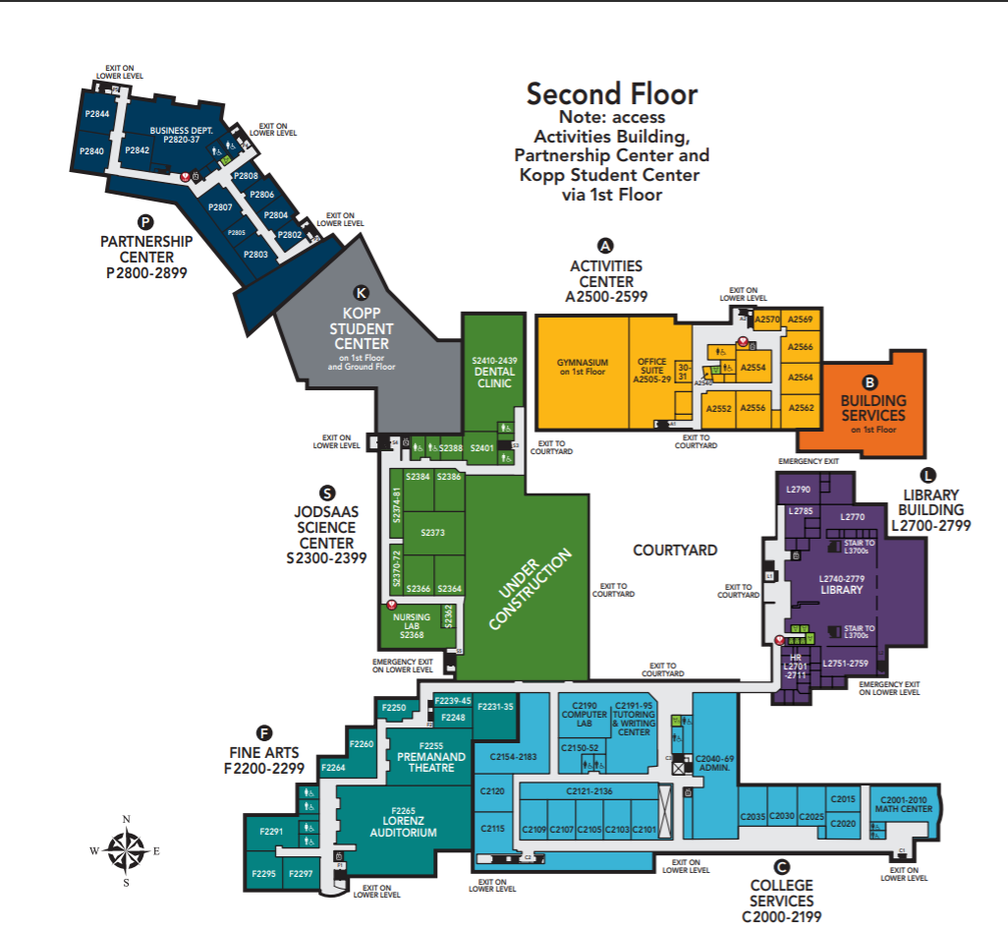
Key
Evacuation Chair Locations Tornado Shelters

Figure 2. Map of Evacuation Chair and Tornado Shelter Locations on Third Floor
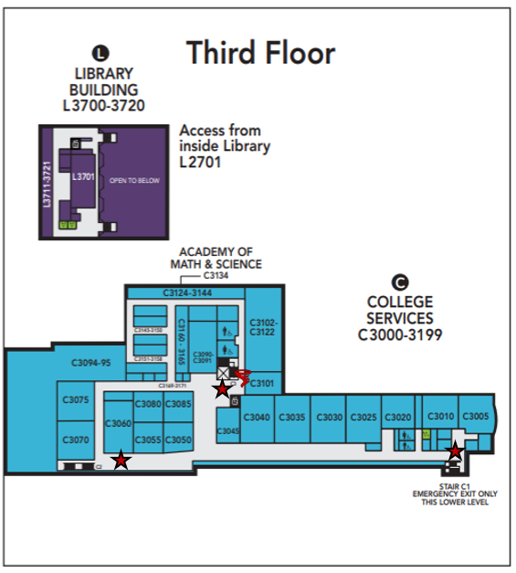
Key
Evacuation Chair Locations Tornado Shelters


Appendix E - Questions & Answers about Interpreting

Who is that person sitting in the front of the room?

Interpreters are professional staff members or contractors who act as interpreters for students who are deaf or hard-of-hearing. They follow a code of ethics that can be found at www.RID.org.

You may feel like you need to introduce or explain their presence to the class, but this is unnecessary and draws attention to the deaf student that may not be desired. The fact that they are there to interpret becomes very quickly apparent to the class. Other students in your class will pay less attention to the interpreter as time goes on and as they become accustomed to having the interpreter in the room.

What can I do?

Speak at your normal speaking rate. Conduct class as you usually do. If there is a problem, the interpreter or the student will let you know.

Use videos and films that are closed captioned. Even if you are showing a video or movie with closed captioning, leave some light on the interpreter. Even with captioning, the student may ask the interpreter for clarification of terms or may desire to have the content interpreted instead. Lighting is very important; the student needs to SEE the signs and facial expressions of the interpreter. If needed, a small spot light can be borrowed from the OSD (Office for Students with Disabilities) staff in L1750.

When speaking to the student who is deaf or hard-of-hearing, speak directly to the student. Avoid phrases like: “Tell him…” or “Ask her…”

For your information…

The interpreter will interpret everything that is said. Also, when the student is signing, the interpreter will voice what is being signed unless they are working out clarification of sign choices. The interpreter is speaking for the student who is deaf or hard-of-hearing. It is not the interpreter’s comments or questions. Please also do not direct questions or comments to the interpreter. Unless the interpreter is asking you for clarification so they can interpret better, it is best that you pretend they are not there.

The goal of interpreters is to facilitate communication. The contracted interpreters do not counsel or teach. Contracted interpreters cannot discuss the student’s progress or behavior. Any questions regarding the student’s programming can be directed to the OSD staff (including the staff interpreter, Geri Wilson).

For Further Information, Contact the Office for Students with Disabilities (OSD) in L1750

Appendix F - Authorization for Release of Student Information Form
